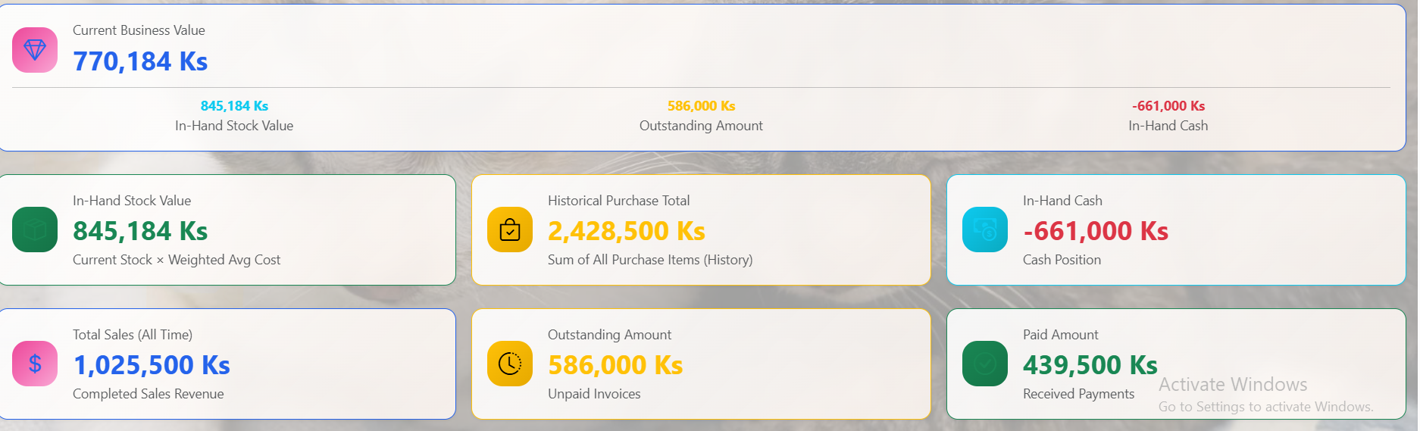
In Hand Stock Value = In Hand Stocks x Unit Price of each.
Historical Purchase Total = Total Purchase Stocks Value
In-Hand Cash = Total sale which are received not outstanding + In-Hand Cash injection.
Outstanding = Total Sale which are not received money
Current Business Value = In Hand Stock Value + Outstanding Amount + In-Hand Cash

